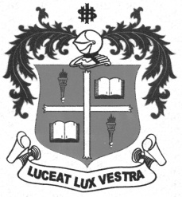
LOYOLA COLLEGE (AUTONOMOUS), CHENNAI – 600 034
B.A. DEGREE EXAMINATION – ECO., SOCIO., & ENGLISH LIT.,
FOURTH SEMESTER – APRIL 2012

HT 4205 / 4201 - WORLD HISTORY

Date : 19-04-2012 Dept. No. Max. : 100 Marks
Time : 1:00 - 4:00

PART – A

ANSWER ANY TEN IN NOT MORE THAN TEN LINES : 10X2=20

- Divine Comedy.
- Sale of Indulgence.
- New World.
- Slave Trade.
- Divine Right Theory
- Steam Engine.
- Reign of Terror.
- Social Contract Theory.
- Cavour.
- ILO.
- Marshall Plan.
- ASEAN

PART – B

ANSWER ANY FOUR OF THE FOLLOWING IN ONE PAGE: 4X10=40

- Explain the influence of Renaissance on Artistic Creativity.
- Give an account of Discoveries of the New Places discovered.
- Estimate the contribution of Dr. Sun Yat Sen to reforms in China.
- Narrate the causes of the First World War.
- State the impact of Cold War on International Relations.
- Highlight the events that transformed Vietnam into a Socialist Republic.

PART – C

ANSWER ANY TWO OF THE FOLLOWING ELABORATELY: 2X20=40

- Trace the history of Reformation Movements since 12th Century .
- Describe the causes, course and results of the French Revolution of 1789.
- Enumerate the role played by Mazzini, Cavour and Garibladi in bringing about the Unification of Italy.
- Discuss the role of UNO and its achievements.

*********

